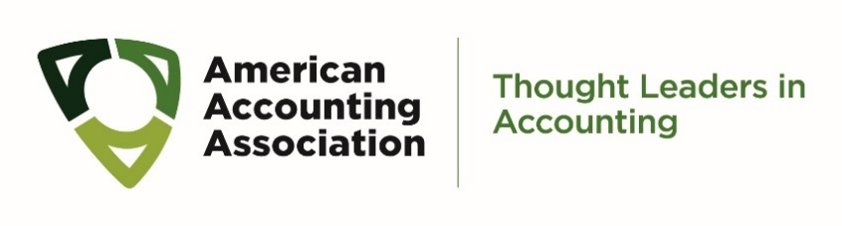
Call for Nominations for
2021-2022 AAA Nominations Committee

Nomination for 2021-2022 Nominations Committee Members

Nominator’s Full Name and Affiliation

Nominee’s Full Name

Nominee’s Affiliation

I confirm that I have contacted the nominee and that s/he is willing to be nominated (Required) ☐ Yes ☐ No

Please share up to five reasons for your nomination.

Options for Submitting This Form

Email:
- Save the completed form to your desktop and attach it to an email to Barbara.gutierrez@aaahq.org
or
- Print the completed form, scan it to your computer, and attach it to an email to Barbara.gutierrez@aaahq.org

Fax:
- Fax the completed form to 941-923-4093; attention Barbara Gutierrez

Submission deadline is Noon EST Monday, March 1, 2021

American Accounting Association| 9009 Town Center Parkway| Lakewood Ranch, FL 34202| 941-921-7747

